Overview

For AMI meter being billed over the air, the interval KWH reads data will be stored in the MDM system. When the account is ready to be billed, SAP sends a profile calculation request to MDM. The MDM system will then calculate the Peak Demand using the interval KWH reads and the Peak Demand is sent to SAP as billing determinant.

This job aid provides information on the MDUS Request and billing determinant.

Business Process Procedure Overview
Overview of MDUS Request througout the billing process

- Profile Calculation request not yet sent
- Profile Calculation request sent. No response received .
- Profile Calculation request sent. Response received.

1.1. Profile Calculation request not yet sent

When the index reads are available and plausible, the billing order with have an Order status = Billable. To determine if the account being billed over the air is ready to be billed, we also need to look at the MDUS Status. When the profile calculation request has not yet been created, the billing order will have an MDUS Status = 01 (Request must be created). At this point, the MDUS Request in the bottom of the screen is not yet checked.

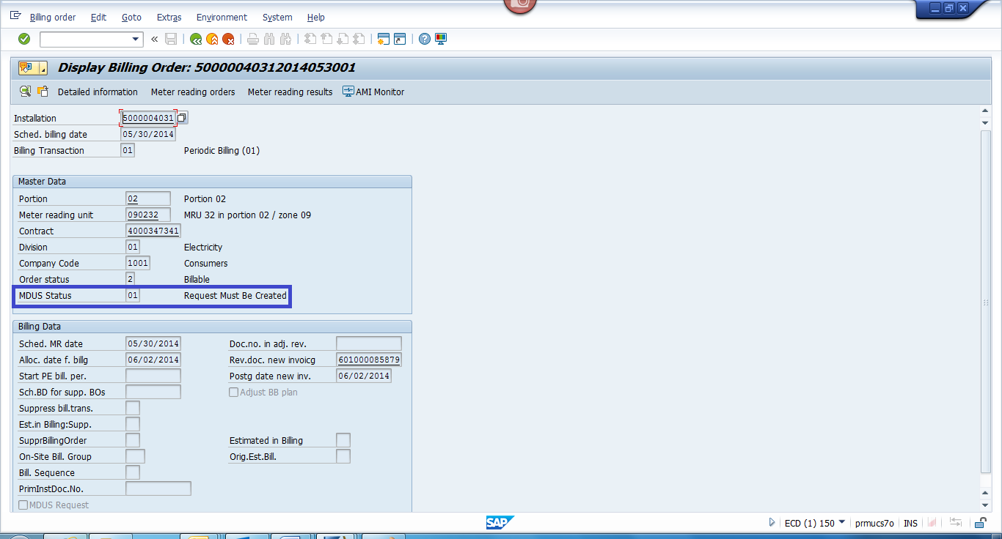

1.2. Profile Calculation request sent. No response received.

The Profile Calculation requests are created by a Redwood Job. It can also be created manually using transaction EMDUSCRTRQ.

When triggering the Profile Calculation request manually using transaction EMDUSCRTRQ, make sure the radio button “Request Must Be Created” is activated.

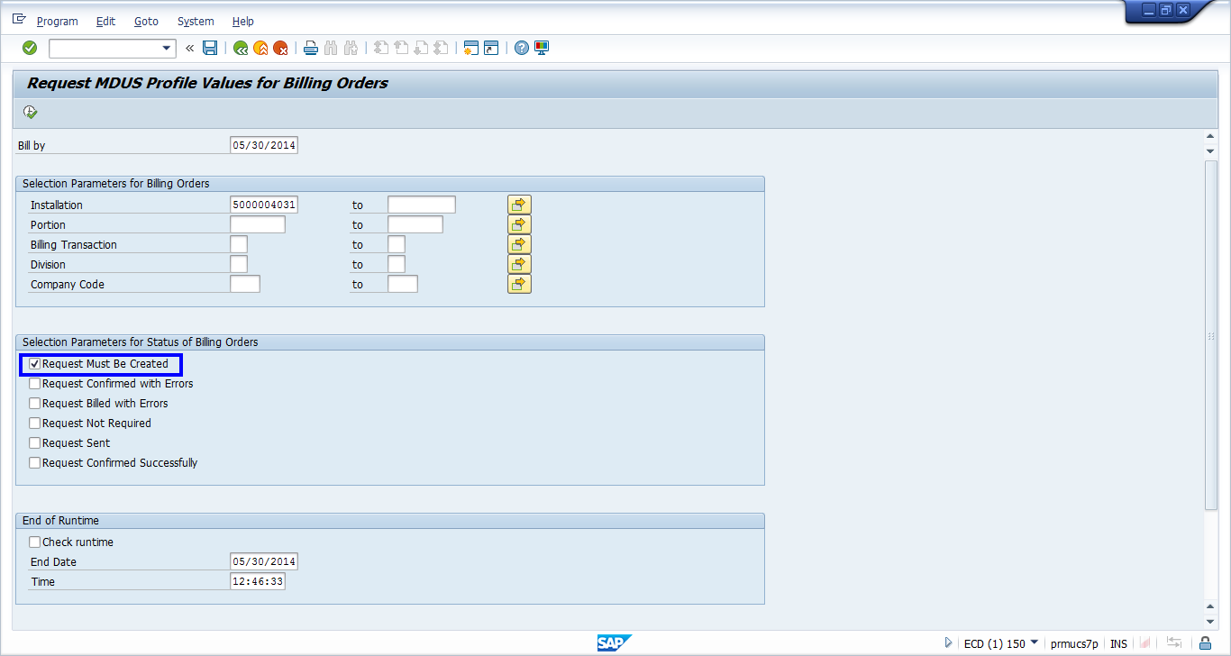

Once the Profile Calculation request has been created, the billing order will have an MDUS Status = 02 (Request Sent).

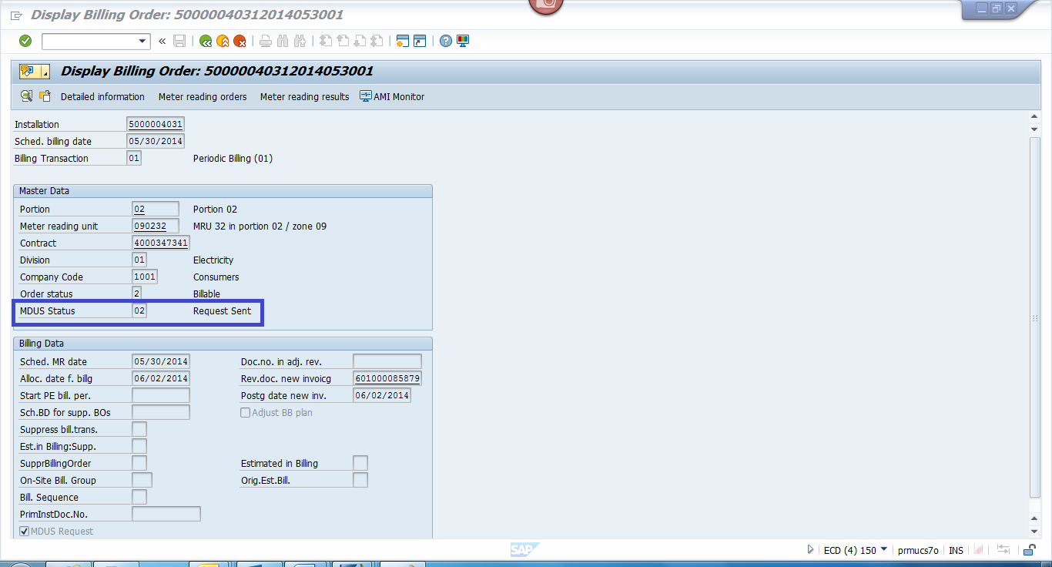

From the Billing Order, you can view the status of the Profile Calculation request by clicking on AMI Monitor button.

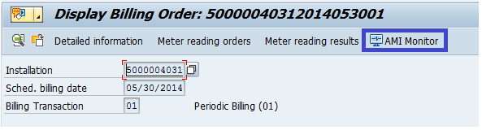

AMI Monitoring screen will be displayed. In the example below, SAP has not received the Profile Calculation response yet, so only the Outbound Message is available. Status will be yellow.

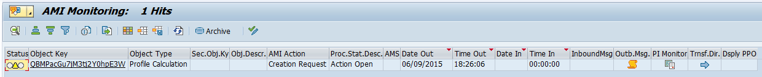

1.3. Profile Calculation request sent. Response received without error.

When SAP receives the Profile Calculation response, the AMI Monitoring screen will reflect the Inbound Message. Status will be green.

The billing order will have an the MDUS Status = 03 (Request Confirmed Successfully).

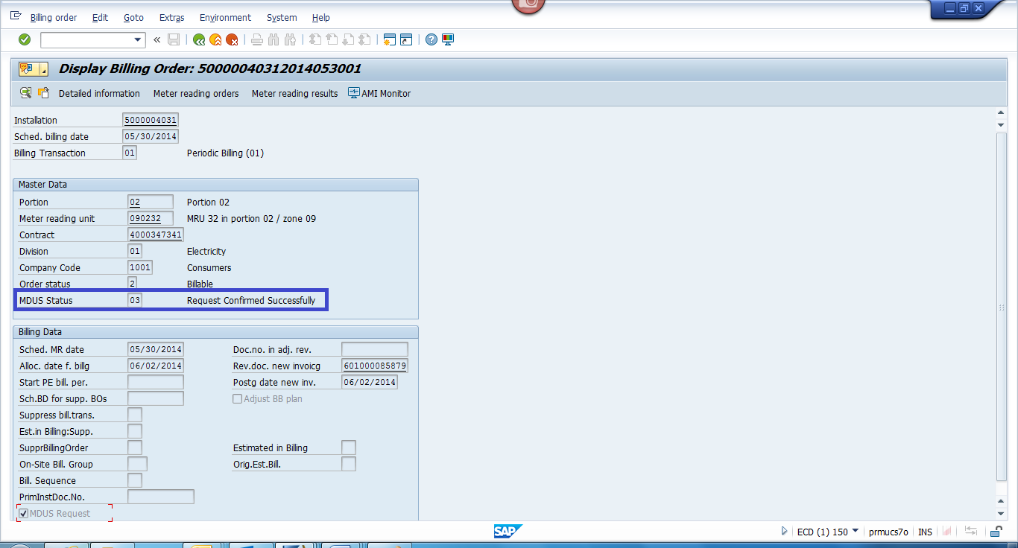
The MDUS Request can be viewed by clicking on the MDUS Request checkbox from the billing order.
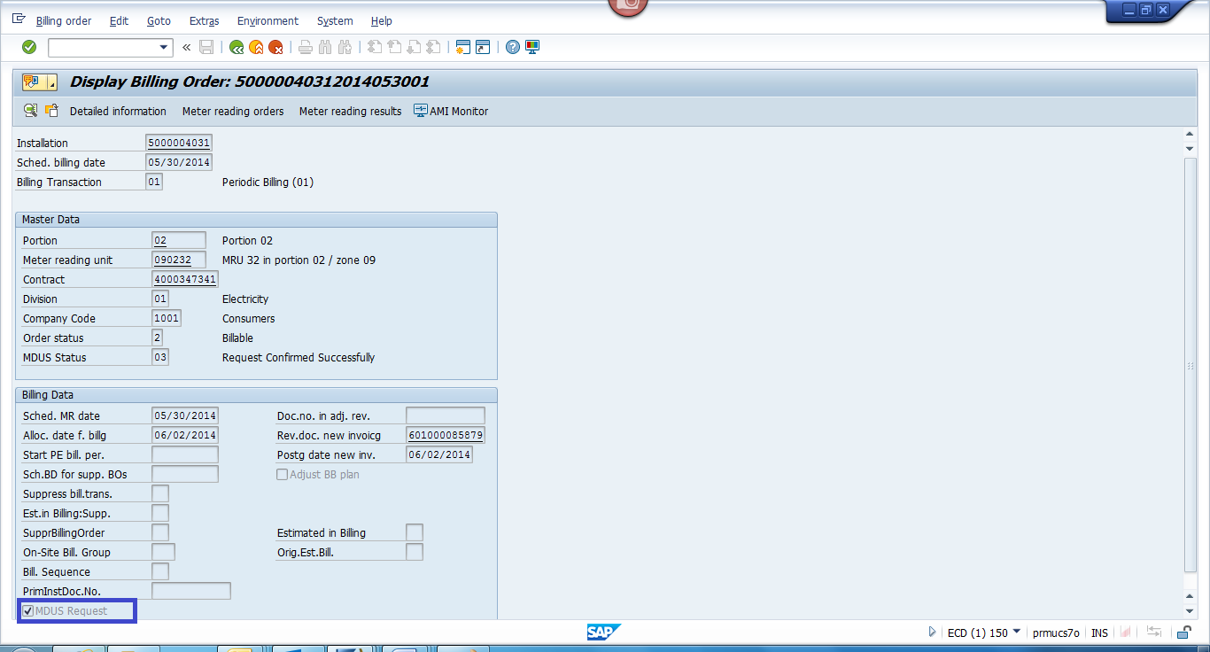

Once billing is complete, the MDUS Request checkbox is also available from the billing document. This is found in the MasterData tab from the Hdr Data.

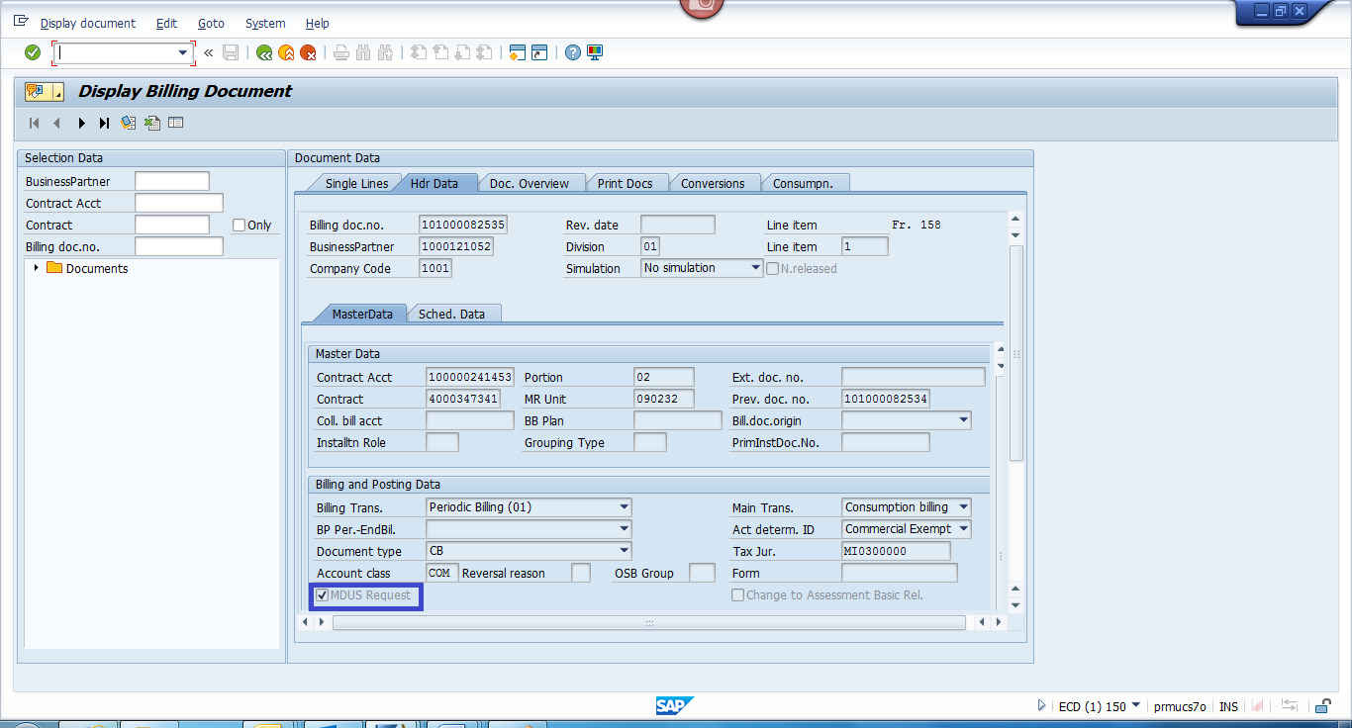

The MDUS Request contains the billing determinant calculated by the MDM. In the example below, the peak demand is 300 calculated from the interval on 05/01/2014 00:15:00.

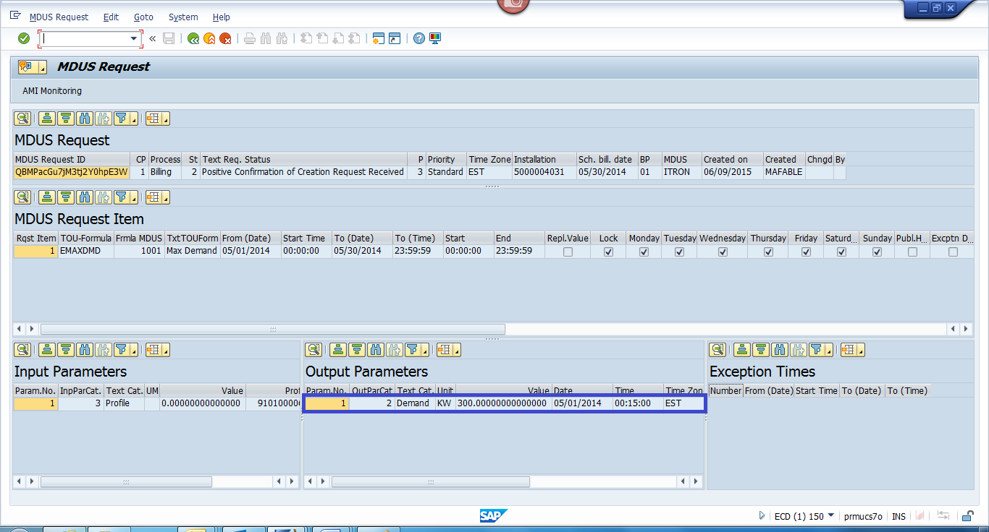

1.4. Profile Calculation request sent. Response received with error.

The billing order will have an the MDUS Status = 04 (Request Confirmed with Errors).
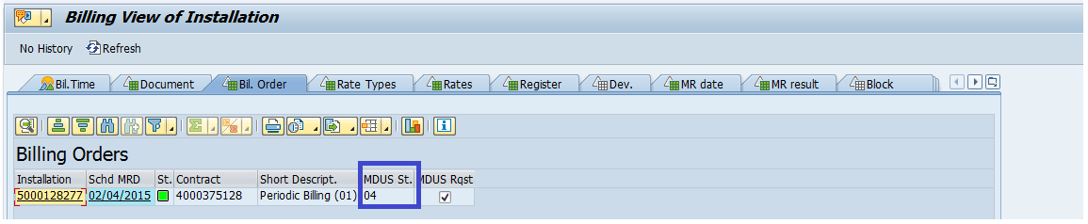

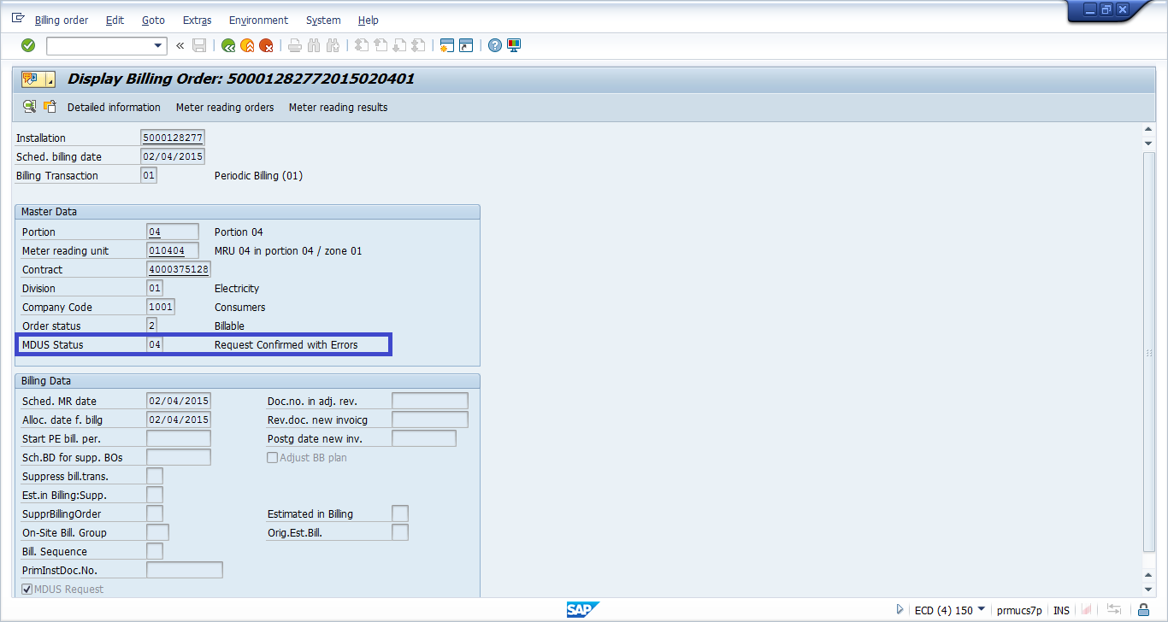

Billing order having an MDUS Request status of 04 will not be picked up in billing.

MDUS Status 04 will have a corresponding BPEM case created with case category EB66 (OTA Demand Missing or Invalid). SEOC needs to be contacted to determine why IEE is returning a billing determinant that’s in error, and needs to get the error resolved. Once the error is resolved, an MDUS Request can be re-sent to IEE to get the billing determinant.

When triggering the MDUS Request to IEE in this case, make sure the radio button “Request Confirmed with Errors” is activated.

